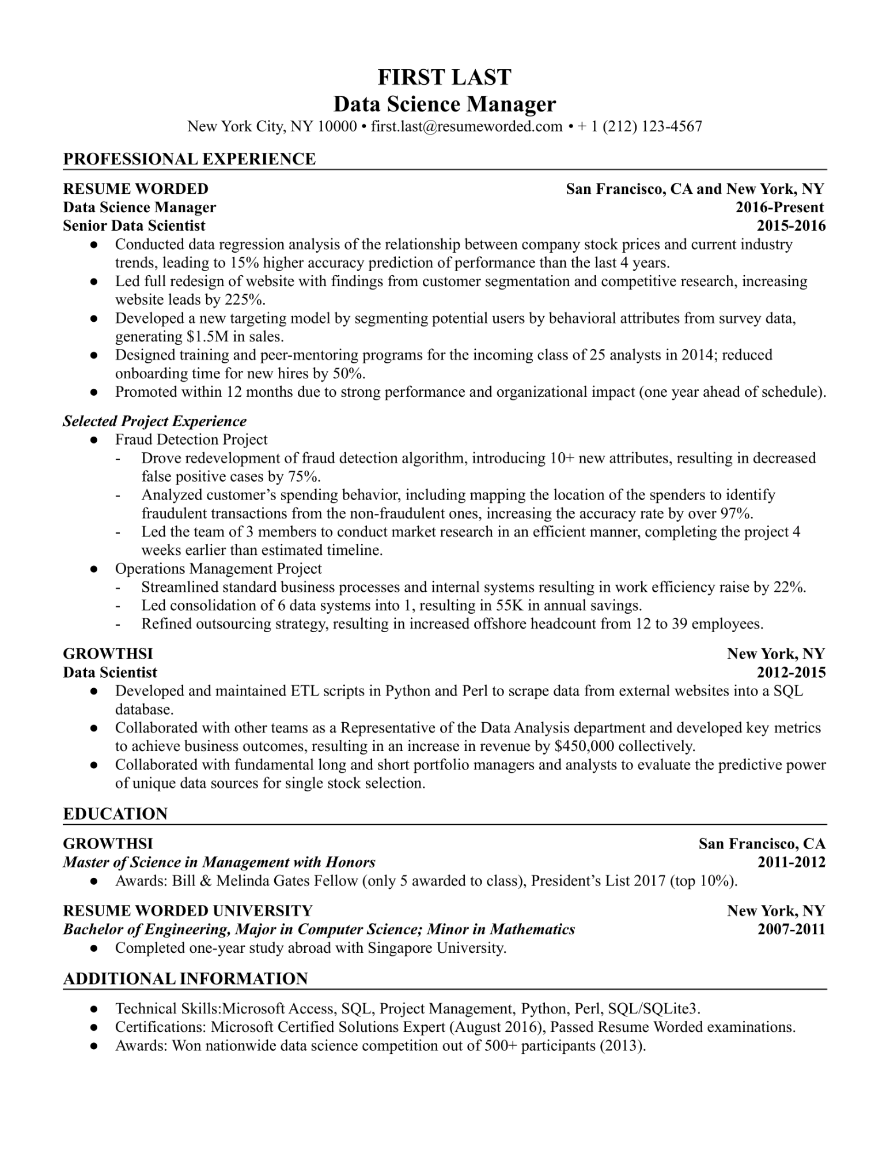
FIRST LAST
Data Science Manager
New York City, NY 10000⚫ first.last@resumeworded.com • + 1 (212) 123-4567
PROFESSIONAL EXPERIENCE
RESUME WORDED Data Science Manager
Senior Data Scientist
•
•
•
San Francisco, CA and New York, NY
2016-Present 2015-2016
Conducted data regression analysis of the relationship between company stock prices and current industry trends, leading to 15% higher accuracy prediction of performance than the last 4 years.
Led full redesign of website with findings from customer segmentation and competitive research, increasing website leads by 225%.
Developed a new targeting model by segmenting potential users by behavioral attributes from survey data, generating $1.5M in sales.
Designed training and peer-mentoring programs for the incoming class of 25 analysts in 2014; reduced onboarding time for new hires by 50%.
• Promoted within 12 months due to strong performance and organizational impact (one year ahead of schedule).
Selected Project Experience
•
Fraud Detection Project
Drove redevelopment of fraud detection algorithm, introducing 10+ new attributes, resulting in decreased false positive cases by 75%.
Analyzed customer's spending behavior, including mapping the location of the spenders to identify fraudulent transactions from the non-fraudulent ones, increasing the accuracy rate by over 97%.
Led the team of 3 members to conduct market research in an efficient manner, completing the project 4 weeks earlier than estimated timeline.
Operations Management Project
Streamlined standard business processes and internal systems resulting in work efficiency raise by 22%. Led consolidation of 6 data systems into 1, resulting in 55K in annual savings.
Refined outsourcing strategy, resulting in increased offshore headcount from 12 to 39 employees.
GROWTHSI
Data Scientist
•
•
•
New York, NY 2012-2015
Developed and maintained ETL scripts in Python and Perl to scrape data from external websites into a SQL database.
Collaborated with other teams as a Representative of the Data Analysis department and developed key metrics to achieve business outcomes, resulting in an increase in revenue by $450,000 collectively. Collaborated with fundamental long and short portfolio managers and analysts to evaluate the predictive power of unique data sources for single stock selection.
EDUCATION
GROWTHSI
Master of Science in Management with Honors
San Francisco, CA 2011-2012
• Awards: Bill & Melinda Gates Fellow (only 5 awarded to class), President's List 2017 (top 10%). RESUME WORDED UNIVERSITY
Bachelor of Engineering, Major in Computer Science; Minor in Mathematics
• Completed one-year study abroad with Singapore University.
ADDITIONAL INFORMATION
New York, NY
2007-2011
Technical Skills:Microsoft Access, SQL, Project Management, Python, Perl, SQL/SQLite3. Certifications: Microsoft Certified Solutions Expert (August 2016), Passed Resume Worded examinations. Awards: Won nationwide data science competition out of 500+ participants (2013).

